SE 4485: Software Engineering Projects

Fall 2026

Detailed Design Documentation

Group Number | 9
Project Title | Skills Catalog & Inventory (Team A)
Sponsoring Company | Sabre Corporation
Sponsor(s) | Jeff Buchmiller
Students | 1.Tobenna Nwosu  2. Jason Lehman  3. Alice Askerup  4. Russel Costales  5. Kim Chau  6. Jasmine Shrestha

Skills Catalog & Inventory

- ABSTRACT
This is the Detailed Design Documentation for the Skills Catalog & Inventory project sponsored by Sabre Corporation. This project is one of the ten projects for this course SE 4485.001 at the University of Texas at Dallas. This document complies with the Software Engineering Standards set by the IEEE Standard for Software Project Management Plans (IEEE Std 1058-1998). The document sets the architectural design and structure for the project.

B. TABLE OF CONTENTS

Abstract……………………………………………………………………………………….…....3
- Table of Contents…………………………………………………………………………….…….4
- List of Figures……………………………………………………………………………………...5
- List of Tables………………………………………………………………………………….……5
- Introduction……………………………………………………………………………….….…….
1.1. Introduction to the document…………………………………………………………….……
1.2. Purpose and Scope of the document…………………………………………………….….…
1.3. Description of the structure of the document………………………………………….………
- GUI (Graphical User Interface) Design
- Static Model
- Dynamic Model
- Rationale for your Detailed Design Model
- Traceability from Requirements to Detailed Design Model
- Evidence the Design Model has been placed under configuration
- Engineering Standards and Multiple Constraints
- Additional References

LIST OF FIGURES

LIST OF TABLES

1. INTRODUCTION

1.1 Introduction to the entire document
The Detailed Design Documentation describes the design details of the Skills Catalog & Inventory (Team A) project. This document provides an overview of the system’s architecture, structure, and the interactions between different components. This document serves as a guide for the team to develop the system by explaining how the system’s requirements will be translated into a detailed design that supports implementation.

1.2 Purpose and scope of the document
The purpose of this Detailed Design Document is to describe the system’s internal structure, user interface design, and interactions between components for the Skills Catalog and Inventory application. It translates the functional and non-functional requirements into a detailed technical design that will guide the implementation, testing, and integration of the system's components. This document will include class diagrams to visually represent the system's classes, attributes, methods, and relationships. The document will also include GUI diagrams to outline the layouts, navigation, and interactive elements of the user interface for each stakeholder role. Sequence diagrams will also be included to demonstrate the order of interaction between users, system components, and the database during key operations. This document and diagrams will serve as a technical reference for the development team to ensure that the system’s architecture and user experience align with the outlined functional and non-functional requirements

1.3 Description of the structure of the document
This Detailed Design Document bridges the gap between the requirements and how it is implemented. The document is organized into the following sections:
- Introduction: Introduces the document while explaining its purpose and scope.
- GUI (Graphical User Interface) Design: Presents the GUI design of the Skills Catalog and Inventory.
- Static Model: Presents the static model of the system using UML class diagrams to show the classes, their attributes and operations, and the relationship among them.
- Dynamic Model: Presents the dynamic model of the system using UML sequence diagrams to show how objects interact over time.
- Rationale for the detailed design model: Gives the rationale for detailed design model while explaining the design decisions, alternatives considered, and the patterns and principles applied.
- Traceability from requirements to detailed design model: Maps requirements in Requirements Documentation to design elements that satisfy it.
- Configuration management: Links to relevant repository management tools.
- Engineering Standards and Multiple Constraints: Lists the industry standards guiding the project.
- Glossary and Additional References: Defines key terms and provides supporting references.

2. GUI (Graphical User Interface) Design
- screen designs (coded or using drawing tool)

3. Static Model
CLASS DIAGRAMS (Captured in draw.io)

- Legend:
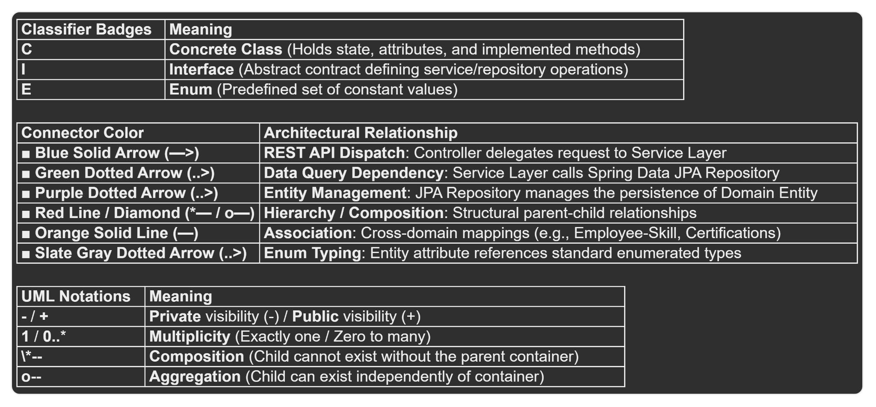

4. Dynamic Model
SEQUENCE DIAGRAMS
- captured in Rose (other tools are also allowed)

5. RATIONALE FOR YOUR DETAILED DESIGN MODEL

6. TRACEABILITY FROM REQUIREMENTS TO DETAILED DESIGN MODEL
- provide a mapping between requirements and detailed design model
- clearly describe how each requirement in the Requirements Documentation is captured in the design

General / Business Operations Functional Requirements | Traces to Detailed Design Model
Import Skills Catalog | DataOpsController.uploadSkills(file) calls ImportExportService.importSkillsCatalog(fileBytes) to import the Skills Catalog data.
Load additional skills | SkillsCatalogController.createSkill(dto) calls SkillsCatalogService.addSkills(skill) to load additional skills.
Validate Imported Data | Missing
View Import Errors/Results | Missing
Export Data | DataOpsController.downloadReport(deptld) calls ImportExportService.exportInventoryReport(deptld) to export the data.
Backup | Missing
Restoration | Missing
Approve or deny additional skills | Approval method available but missing denial method
Web-based system | REST Controllers, including OrganizationController, SkillsCatalogController, SkillsInventoryController, and DataOpsController, provide endpoints for communication with the web-based front-end.
Cancel | Missing

Workforce Planner Functional Requirements | Traces to Detailed Design Model
Views Skills Catalog
Add Skills
Update Skills
Search Skills
View Skills Details
Maintain Skill Type
Skill Proficiency Levels
Graphical UI
AI assistance

Resource Manager Functional Requirements | Traces to Detailed Design Model
Creating/Maintaining Skills Inventory
Search for a specific resource or organization to view their skills
Search for a specific skill and see all associated resources
View UI
Create, view, and maintain association between skill and resource
View specific Skill UI
Skill Validation
Certification Tracking

Organizational Leader Functional Requirements | Traces to Detailed Design Model
View summary
Filter Skills
View distribution
Graphical views
Skill capacity
Skill Trend & Historical Analytics
Organization Hierarchy

7. Configuration Management
- Github Repository: https://github.com/kimchau123/SE-4385-Group-9

Name | Version Before | Version After | Difference between 2 consecutive versions | Review | Comments
Tobenna | 0.00 | 0.01 | Documented Created | Shipped | Start of Our Detailed Design documentation
Tobenna | 0.01 | 0.02 | Template Added to Document | Shipped
Jasmine | 0.02 | 0.03 | Abstract | Shipped
Kim | 0.03 | 0.04 | Introduction to the entire document | Shipped
Jason | 0.04 | 0.05 | Purpose and Scope | Shipped
Jasmine | 0.05 | 0.06 | Description of the structure of the document | Shipped
Kim | 0.06 | 0.07 | Traceability from requirements to detailed design model | In progress
Tobenna | 0.07 | 0.08 | Static Model | In Progress

8. Engineering Standards and Multiple Constraints

- IEEE Std 1016-1998-(Revision-2009): Software Design [pdf]

Students should work with their project sponsor(s) to identify all the standards and constraints that should be applied for preparing this document. Additional materials that are not listed above can be included.

9. Glossary

- Additional References

- Larman, C., 2012. Applying UML and Patterns: An Introduction to Object Oriented Analysis and Design and Iterative Development. Pearson Education
- Hyman, B., 1998. Fundamentals of Engineering Design. New Jersey: Prentice Hall
- Simon, H.A., 2014. A Student's Introduction to Engineering Design: Pergamon Unified Engineering Series (Vol. 21). Elsevier

Each group may include other related references that are not listed above.

